Principal: ____________ Interest rate: ____________ How many years? ____________ Which one are you using? _________(use Decision tree)
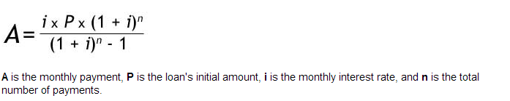
End of the year = Future value of an ordinary annuity
Beginning of the year = Future value of an annuity due
None = Future value
Beginning of the year = Present value of an annuity due
None = Present value
Loan amortization
Decision Tree
End of the year = Present value of an ordinary annuity
Present
Future

