**Module 4: Practice Problems**

**PART 1: SUPPLY AND DEMAND**

**PROBLEM #1**

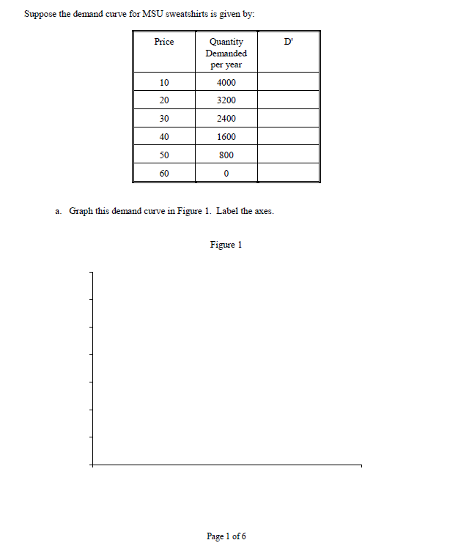

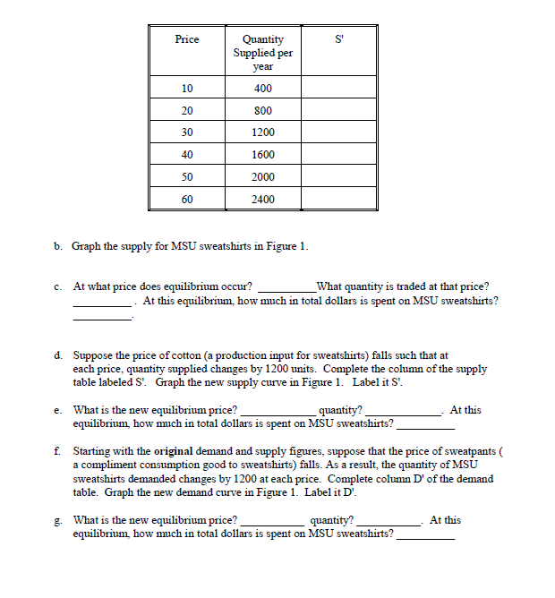

**PROBLEM #2**

Create a demand graph using the following table of values:

|  |  |
| --- | --- |
| PRICE | QUANTITY |
| 10 | 500 |
| 20 | 450 |
| 30 | 400 |
| 40 | 350 |
| 50 | 300 |
| 60 | 250 |

1. What is the quantity demanded at $60? ___________________________
2. What is the price people are willing to pay for a quantity of 400? ___________________________

Create a supply graph using the following table of values:

|  |  |
| --- | --- |
| PRICE | QUANTITY |
| 10 | 200 |
| 20 | 250 |
| 30 | 300 |
| 40 | 350 |
| 50 | 400 |
| 60 | 450 |

1. What is the quantity supplied at $60? ___________________________
2. What is the price people are willing to provide for a quantity of 400? ___________________________

Create a graph by plotting the quantities both tables above into the graph below. After your plots are done, indicate market equilibrium. Be sure to label the X and Y axis.

What is the market equilibrium? ______________________________________________

**PROBLEM #3**

Suppose the demand curve for CSU sweatshirts is given by:

|  |  |
| --- | --- |
| Price | Quantity demanded per year |
| 10 | 4000 |
| 20 | 3200 |
| 30 | 2400 |
| 40 | 1600 |
| 50 | 800 |
| 60 | 0 |

Suppose the supply curve for CSU sweatshirts is given by:

|  |  |
| --- | --- |
| Price | Quantity demanded per year |
| 10 | 400 |
| 20 | 800 |
| 30 | 1200 |
| 40 | 1600 |
| 50 | 2000 |
| 60 | 2400 |

Answer the following

1. Draw the s/d curve
2. At what price does equilibrium occur? __________
3. What quantity is traded at that price? ______________
4. At this equilibrium, how much in total dollars is spent on CSU sweatshirts? _________

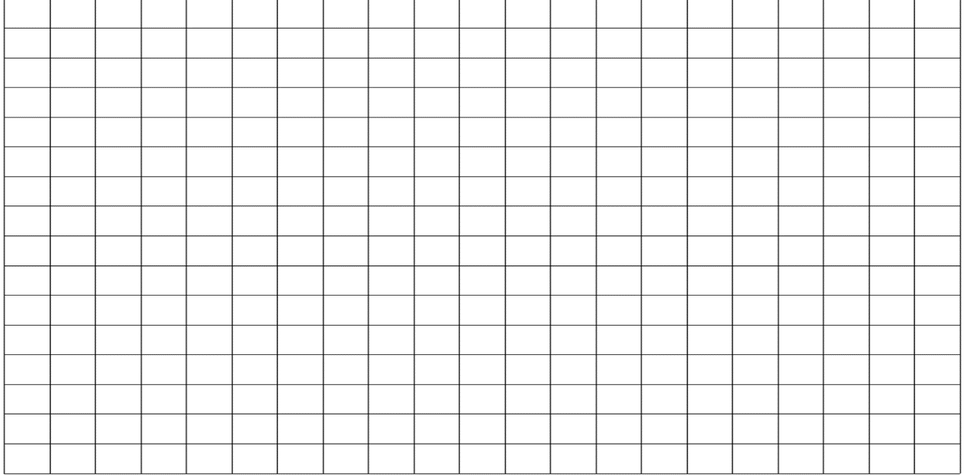

**PART 2: SHORTAGE-SURPLUS**

**PROBLEM #4**

Imagine that you have opened a small business in your school selling Italian ices. You make the ices from fresh fruit – lemons, oranges, blueberries and cherries - using a family recipe that your grandfather has passed along. You are concerned about the price you pay for the fruit, as the price you pay for the ingredients is reflected in the price you charge your customers, and you are aware that there is a limit to what your customers are willing to pay. Although you would like to offer variety to your customers, if the price of any of the fruits becomes too high, you will cut back on your purchases, and offer less of that flavor to your customers. The quantity of lemons you are willing to purchase at various prices per bushel is presented in the table below.

The lemon supplier obtains lemons directly from growers in Florida and has a variety of customers that include restaurants, supermarkets and fruit vendors.

**The quantity of lemons you are willing to purchase and the quantity of lemons the supplier is willing to offer at various prices per bushel are presented in the table below. For each price per bushel in the table: indicate whether there is a shortage, shortage, or neither**

|  |  |  |  |
| --- | --- | --- | --- |
| Price per bushel | Quantity demanded (D) | Quantity supplied (S) | Surplus or shortage |
| $40 | 20 | 60 |  |
| $32 | 30 | 50 |  |
| $24 | 40 | 40 |  |
| $16 | 50 | 30 |  |
| $8 | 60 | 20 |  |

**PART 3: Price Ceilings and Price Floors**

**Problem #5**

A store sells cheddar cheese by the pound. The chart reflects the quantity demanded and the quantity supplied for the different prices the cheese could be sold.

|  |  |  |
| --- | --- | --- |
| Price | Quantity Demanded | Quantity Supplied |
| $6.00 | 220 | 400 |
| $5.50 | 240 | 360 |
| $5.00 | 260 | 320 |
| $4.50 | 280 | 280 |
| $4.00 | 300 | 240 |
| $3.50 | 320 | 200 |
| $3.00 | 340 | 160 |

**Use the data to plot demand and supply curves.**



**Answer the following questions:**

a. What is the market price?

b. What is the quantity demanded at the market price?

c. What is the quantity supplied at the market price?

**On your graph, draw a line across your graph at the price of $4.00.**

a. If the government were to set a price no higher than $4.00, this would be called a .

b. Use your answer in (a) to label the line on your graph at the price of $4.00.

c. At a price of $4.00, the quantity demanded would be

d. At a price of $4.00, the quantity supplied would be

e. Is there a surplus or shortage of cheese?

**On your graph, draw a line across your graph at the price of $5.50.**

a. If the government were to set a price no lower than $5.50, this would be called a

b. Use your answer in (a) to label the line on your graph at the price of $5.50.

c. At a price of $5.50, the quantity demanded would be

d. At a price of $5.50, the quantity supplied would be

e. Is there a surplus or shortage of cheese?

**PART 4: SUPPLY AND DEMAND SHIFTS**

**Problem #6**

**Shift in Demand**

****Scenario: The following schedule shows a change in demand based on the price of a related product. The demand increased for CDs because the price of CD players dropped.

1 2 3 4 5 6 7 8 9 10 11 12 13 14 15

|  |  |  |  |  |
| --- | --- | --- | --- | --- |
| Price Per Compact Disc | Quantity Demanded (CD Players $75) | Quantity Demanded (CD Players $50) | Quantity Supplied |  |
| $6 | 0 | 4 | 9 |  |
| 5 | 2 | 6 | 6 |  |
| 4 | 3 | 7 | 5 |  |
| 3 | 4 | 8 | 4 |  |
| 2 | 6 | 11 | 3 |  |
| 1 | 9 | 13 | 0 |  |

1. What type of demand shifter does the following describe? _________________________________________
2. What happened to the original demand curve, did it shift left or right? ______________________________________________
3. What is the effect on P? ___________________________________________________
4. What is the effect on Q? ___________________________________________________

Problem #7

**Shift in Supply**

Scenario: The following schedule shows a change in supply based on new technology and methods of producing CDs. The supply increased for CDs because the new technology allowed the supplier to produce CDs at a reduced rate.



1 2 3 4 5 6 7 8 9 10 11 12 13 14 15

|  |  |  |  |  |
| --- | --- | --- | --- | --- |
| Price Per Compact Disc | Quantity Demanded | Quantity Supplied (old technology) | Quantity Supplied (new technology) |  |
| $6 | 0 | 9 | 14 |  |
| 5 | 2 | 6 | 12 |  |
| 4 | 3 | 5 | 10 |  |
| 3 | 4 | 4 | 8 |  |
| 2 | 6 | 3 | 6 |  |
| 1 | 9 | 0 | 3 |  |

1. What type of supply shifter does the following describe? _________________________________________
2. What happened to the original supply curve, did it shift left or right? ______________________________________________
3. What is the effect on P? ___________________________________________________
4. What is the effect on Q? ___________________________________________________

**PROBLEM #8**

For each of the following problems, state which curve would shift (supply or demand). Then state whether it would shift left or right, then state which of the type of shifter it is referring to.

|  |  |  |  |  |
| --- | --- | --- | --- | --- |
| MARKET | EVENT | WHICH SHIFTS? | WHICH WAY? | WHY SHIFT? |
| WHEAT | A drought destroys much of the crop | Supply | Left | Productivity and technology |
| Butter | The price of margin goes up |  |  |  |
| Wine | The average wage of grape harvesters rises by 10% |  |  |  |
| Hamburger | The price of hamburger rises |  |  |  |
| Hospital beds | Scientists discover a pill that cures cancer |  |  |  |
| Oreo cookies | The price of milk increases |  |  |  |

**PROBLEM #9**

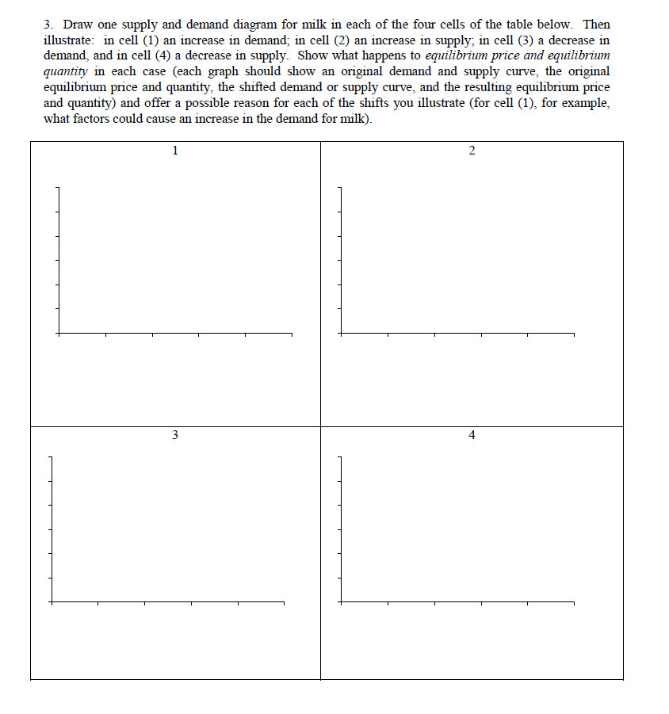

1. Box 1: ___________________________________________________________________________________________
2. Box 2: ___________________________________________________________________________________________
3. Box 3: ___________________________________________________________________________________________
4. Box 4: ____________________________________________________________________________________________

**PROBLEM 10**

**Read the following scenarios and determine if it is a shift in supply or a shift in demand. Which shift is it? (Which of the 5 demand shifters or 6 supply shifts). Determines what happens to the P and what happens to Q due to the shift. What happens to the demand of coffee in the following scenarios?**

1. **A blight on coffee plants kills off much of the Brazilian crop**
   1. Is it a demand or supply shifter? ____________________________________________
   2. What type of shift does the scenario describe? ________________________________
   3. What happens to P? ___________________________________
   4. What happens to Q? __________________________________
2. **Coffee is shown to cause cancer in laboratory rats**
   1. Is it a demand or supply shifter? ____________________________________________
   2. What type of shift does the scenario describe? ________________________________
   3. What happens to P? ___________________________________
   4. What happens to Q? __________________________________
3. **Coffee workers organize themselves into a union and gain higher wages**
   1. Is it a demand or supply shifter? ____________________________________________
   2. What type of shift does the scenario describe? ________________________________
   3. What happens to P? ___________________________________
   4. What happens to Q? __________________________________
4. **Price of tea declines**
   1. Is it a demand or supply shifter? ____________________________________________
   2. What type of shift does the scenario describe? ________________________________
   3. What happens to P? ___________________________________
   4. What happens to Q? __________________________________

**PART 5: ELASTICITY**

**PROBLEM #11**

Determine if the following goods are elastic or inelastic based on the scenario

1. Home heating oil = It is 2015 and homes are heated by oil, electricity, or gas. Elastic or Inelastic
2. Pepsi = A person wants a Pepsi to go with her dinner and at the restaurant they only serve Coca-Cola. Elastic or Inelastic
3. Chocolate = An individual is craving something sweet. Elastic or Inelastic
4. Water = At a marathon, water is the only beverage offered to individuals running the race. Elastic or Inelastic

**PROBLEM #12**

For each of the following, write a scenario in which the good/service in elastic and when it is inelastic

1. Salt
   1. Elastic ___________________________________________________________
   2. Inelastic __________________________________________________________
2. Pork chops
   1. Elastic ___________________________________________________________
   2. Inelastic __________________________________________________________
3. European vacation trip:
   1. Elastic ___________________________________________________________
   2. Inelastic __________________________________________________________
4. Insulin
   1. Elastic ___________________________________________________________
   2. Inelastic __________________________________________________________
5. Treatment for depression
   1. Elastic ___________________________________________________________
   2. Inelastic __________________________________________________________

**PROBLEM #13**

My niece decides to grow tomatoes in her family’s garden to sell to her parent’s friends, families, and neighbors. Her first crop of tomatoes yielded 40 pounds of tomato and she charged $0.35 for each tomato. At that value, she sold 30 pounds of tomatoes. Between school and selling tomatoes, she didn’t notice that there is a bigger, more delicious set of tomatoes ripening. It yielded 65 pounds of tomatoes and she plans to charge $0.35 for the tomatoes. Before she leaves, her uncle stops and tells her she doesn’t know the PED on her tomatoes. He suspects that the better tomato will sell out the entire 65 pounds and she should charge more. How much should she charge for the tomatoes if they suspect a PED to be 0.2 (Round to the nearest hundredth)? ____________________________________

**PROBLEM #14**

Your friend Louise owns a cupcake shop that specializes in very unique cupcakes. Every day she has a unique flavor based on different ideas such as popular drinks (alcoholic and non-alcoholic), different cuisines from other countries, holidays, etc. Although there are multiple cupcake shops in her city, hers is the only one that provides these unique flavors. She has just returned from winning the biggest prize ever on Cupcake Wars. Due to her success, she is interested in raising her prices. Based on you learned about price elasticity, answer the following questions.

1. Describe to her what price elasticity of demand is and why she needs to know about it before she raises her price. ___________________________________________________________________________________________________________________________________________________________________________________________________________________________________
2. Assume her cupcakes are inelastic.
   1. What information in the above scenario would make you assume her cupcakes are inelastic? ________________________________________________________________________
   2. Next, draw a normal supply and demand curve then on the same graph, draw an inelastic demand curve. You need to label the X and Y axis; each curve; the P/Q for the normal and inelastic demand curve.



* 1. Describe how it would affect the quantity sold and the price she can charge for her cupcakes, assuming the demand for her cupcakes are inelastic. ___________________________________________________________________________________________________________________________________________________________________________________________________________________________________________________________________________________________________________________________

**PROBLEM #15**

**Determine the PED and determine if it is an elastic or inelastic good/service. Round to the nearest hundredth Finally, determine what should be done based on the information.**

1. Katherine advertises to sell cookies for $4 dozen. She sells 50 dozen, and decides that she can charge more. She raises the price to $6/dozen and sells 40 dozen.
   1. PED? ______________________________________________
   2. Elastic or inelastic? _________________________________________
   3. What should Katherine do? __________________________________________
2. I sell handmade bracelets for $5.00. I market it to businesses that will sell it in their stores. At that price, businesses will buy 15 at a time. I decide to push it to $6.00 for each bracelet, and the result is that businesses now will only buy 10 at a time.
   1. PED? ______________________________________________
   2. Elastic or inelastic? _________________________________________
   3. What should I do? __________________________________________
3. I grow a unique coffee. I used to sell it for $10 a pound and now I sell it for $8 a pound. I go from selling 100 to selling 110.
   1. PED? ______________________________________________
   2. Elastic or inelastic? _________________________________________
   3. What should I do? __________________________________________
4. Whole wheat bread became popular after the $2.00 price fell by twenty-five cents. Because of this, sales rose from 110 to 118 units.
   1. What was the PED of the product? _______________________
   2. Is it an elastic or inelastic good? __________________________
   3. What should be done? _______________________________________
5. Hillary’s homemade jams were moving slowly in February, but she found the secret of boosting sales when she lowered the price from above the dollar barrier (at $1.05) to just below it (at $0.99). Sales jumped from 80 units to a more acceptable 100.
   1. What was the PED? ________________________________
   2. Is it an elastic or inelastic good? __________________________
   3. What should be done? _______________________________________